Final Project

Operational Risk Management Proposal

Michael Surdek
Southern New Hampshire University
DAT 610: Optimazation & Risk Assessment
Professor Kyle Camac
December 12, 2021
1. Risk Assessment Techniques and Practices
Organizational Background and Goals
Company XYZ is an organization that provides property & casualty insurance coverage. According to an internal risk assessment, they are experiencing greater operational losses than they had expected, seemingly due to fraudelent injury claims from automobile accidents. For this reason, Company XYZ has decided to bolster its operational risk program, with the hopes of creating a high-level function alongside their existing market, credit, and insurance risk programs. The company has an industry-standard special investigations unit (SIU) in place, but it is understaffed and overwhelmed by a high volume of these auto accident bodily injury claims. The main goal of the operational risk program is to support the SIU through data analytics. To accomplish this, the program must include a ranking of the most suspicious claims as well as a comprehensive risk management system that can consolidate risk data across the organization and provide visualizations of internal and external loss data.
Established Programs, Policies, Strategies, and Practices
Company XYZ has some established programs, policies, strategies, and practices that will assist with their operational risk assessment objectives. First, they have shown a strong history of using data analytics for managaing market, credit, and insurance risks. This will not only provide experience and resources for their operational risk program, but it also means they have an organizational culture that supports informed decision making. Second, they already have the ability to identify potential fraud with their claims adjudication system. Although it has been identifying an overwhelming amount of claims to investiage, this system can serve as a starting point for ranking the most suspicious claims as the highest priorities. Finally, along the lines of Company XYZ’s analytical culture, they have already demonstrated their commitment to effective risk management by executing the risk and control self-assessment that initially revealed this operational weakness.
Recommended Techniques and Practices
One focus of this operational risk program for Company XYZ should be creating the program as a new function within the organization. Incorporating risk management within IT, compliance, or other functions is one of the most common mistakes that organizations make. (Idnani) On the other hand, an independpent risk management function is more effective and can even become a competitive advantage. This strategy is more flexibile and transparent, it establishes partnerships and relationships across the organization, and it encourages informed risk taking. (Idnani)
Company XYZ should also look at purchasing a risk management system from a third party vendor, such as LogicGate or Sword GRC. The Sword Active Risk Manager product is a complete risk managent solution used by organizations of all sizes, including NASA. This system is cloud-based and configurable, meaning it provides a single view of operational risk. Company XYZ’s risk professionals would be able to access and analyze information through reports, dashboards, alerts, and notifications. Additionally, buying in to an ERM system at the highest level embeds risk awareness into the culture of an organization. “Increasing the focus on risk...allows risk to be considered more openly and breaks down silos with respect to how risk is managed.” (Kreiser)
Active Risk Manager supports flexible scoring as well, which may accomplish their goal of ranking suspicious claims. This functionality “provides the flexibility to qualitatively track emerging risks and concerns with ease while enabling more robust quantitative assessment and treatment of risks that have a material impact on the organization.” (Sword-GRC) On top of simply ranking, the system can integrate with the schedules and assignments of SIU team members and improve their overall productivtity. For these reasons, a risk management system such as Sword Active Risk Manager will signficantly bolster Company XYZ’s operational risk management.

2. Enterprise Risk Management Tools
Risk Assessment and Management Tool Recommendations
The ERM tools that I would recommend for Company XYZ are:
- LogicGate Risk Cloud
- Sword GRC Active Risk Manager
- Onspring Enterprise Risk Management
All of these tools offer integrated solutions for managing enterprise risk, which can come in the form of market, credit, or operational risks. Each tool’s webpage promotes it’s ability to manage GRC, which stands for governance, risk, and compliance. Onspring, the ERM system of choice for companies like Farmer’s Insurance and Western Union, appears quite capable of evaluating credit risks. The LogicGate Risk Cloud site declares that it powers agile risk management across industries such as banking and investment services, likely focuing on market risk evaluation. Sword Active Risk Manager, used by organizations of all sizes including NASA, seems best suited to evaluate operational risk that arises from failed processes, people, systems, and external events.
Company XYZ’s main objectives for purchasing an Enterprise Risk Management system are to rank claims in terms of potential fraud and to identify the most suspicious claims for their Special Investigations Unit. Active Risk Manager can support these goals with what they call flexible scoring, as previously described. The ability to analyze claims both qualitatively and quantitatively is what makes this the best tool for Company XYZ.
Qualitative analysis, such as simply ranking risks as high, medium, or low, can help determine investiagtional priorities. Quantitative analysis can then assist the investigations by providing information and identifying critical factors. In addition to ranking and analyzing the claims, the system can also be integrated with the schedules and assignments of SIU team members and therfore improve their overall productivtity. Since Company XYZ has a strong history of using data analytics to manage market, credit, and insurance risk, the best enterprise risk management tool for them is Sword Active Risk Manager, which will not only mitigate their largest operational risks but also improve their business processes.
3. Visualization Recommendations
Industry Standard Techniques
With increasing standards and regulations as well as technological capabilities, operational risk event data is being collected and analyzed more than ever before. One common analysis method is data visualization. Data visualization is the process of communicating information to an audience in an easily digestible way. “Graphs and charts let you explore and learn about the structure of the information you collect. Good data visualizations also make it easier to communicate your ideas and findings to other people.” (Healy, 2019) Data of all kinds can be represented through visual properties such as length, size, position, shape and color. Effective data visualization often includes the highlighting of key elements or the labeling of items of interest. Additionally, data visualization supports the analytical process because it can cover either the original dataset or elements from statistical models that have been developed.
Visualization Strategies
As an organization’s risk management framework matures, the need for visualization of operational risk event data grows. Data visualization can support various forms of risk-related communication such as weekly committee meetings, daily reports, and day-to-day analysis. For this reason, the data visualization process evolves from its initial stage through repeatable, defined, and managed stages before reaching the optimization stage, as shown in the figure below. (Protiviti, 2006) The responsibilities of a data visualization practicioner also change as the process evolves. At first, they might undertake one-off requests from risk managers. They will be developing an understanding of the available data and producing the analysis that seems most important in the early stages. This will often include risk identification, which is a critical aspect of risk management. “Graphic representations of risks...help to prevent that one focuses only on the most pressing problems.” (Eppler, 2009) Eventually, pipelines for the data and basic analysis are established and visualization efforts can be directed towards statistical analysis and continuous feedback.
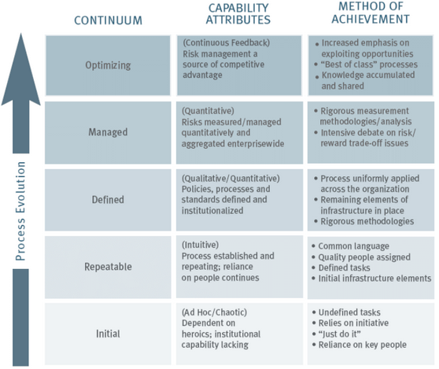
There are various tools and techniques that best serve an organization’s objectives as each stage in the process. These tools allow data visualization practicioners to create charts and graphs and to even embed them into reports or interactive dashboards. In the early stages, point and click software systems such as Tableau, Spotfire, and Power BI are effective tools for ad-hoc and repeatable anlaysis requests. They can connect to sources of data whether they are stored in flat files or in enterprise databases and they provide a simple user interface to customize the analysis. In later stages, most organizations will turn to code-based visualization tools. These tools include the matplotlib and ggplot2 libraries for creating visualizations in python and R, respectively. They can also be easily integrated with report and dashboard developing packages such as rmarkdown, r shiny, and python dash. Finally, if an organization prefers to use a pre-packaged data visualization tool, most enterprise risk management software products, such as Sword Active Risk Manager, offer visualization methods that are tailored to risk analysis.
Data visualization can certainly support Company XYZ’s programs, policies, and strategies for risk management. Between the corporate operational risk function that they are establishing and their objective of enhancing the Special Investigation Unit, data visualization will play a key role in communicating important risk information. Even in the initial stages, there are many ways Company XYZ can leverage data visualization through their internal claims file and additional information that they can gather from external sources. For example, they could plot the amounts claimed v the amounts paid for each claim and they could include the claim suspicion score to see if there is any relationship between the likelihood of fraud and whether or not it is improving their abilities to investigate and resolve suspicious claims.
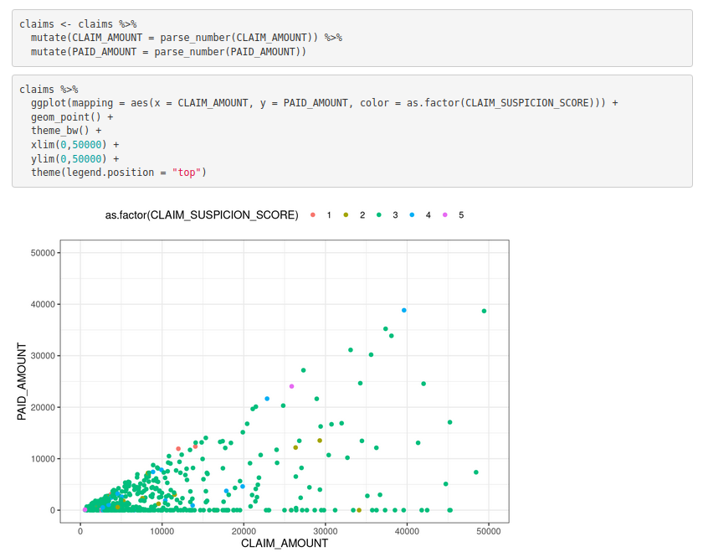
References:

Eppler, Martin & Aeschimann, Markus. (2009). A systematic framework for risk visualization in risk management and communication. Università della Svizzera italiana. Retrieved from
https://www.researchgate.net/publication/228533068_A_systematic_framework_for_risk_
visualization_in_risk_management_and_communication

Healy, Kieran. (2019). Data Visualization: A Practical Introduction. Princeton University Press.

Idnani, Nitish. (2017). Operational risk management: The new differentiator. Deloitte Risk and Financial Advisory. Retrieved from https://www2.deloitte.com/us/en/pages/risk/articles/
operational-risk-management-steps- competitive-advantage.html

Kreiser, Jim. (2013). Five Benefits of Enterprise Risk Management. CliftonLarsonAllen. Retrieved from https://www.claconnect.com/resources/articles/five-benefits-of-enterprise-risk- management

LogicGate. (2021). Welcome to The LogicGate Risk Cloud. LogicGate. Retrieved from https://www.logicgate.com/logicgate-platform/

Onspring. (2021). Enterprise Solution for Risk Management. Onspring. Retrieved from https://onspring.com/solutions/governance-risk-compliance/risk-management/

Protiviti. (2006). Guide to Enterprise Risk Management. Protiviti Insights. Retrieved from https://www.protiviti.com/US-en/insights/guide-enterprise-risk-management

Sword-GRC. (2021). Sword Active Risk Manager Book A Demo. Sword-GRC. Retrieved from https://sword-grc.com/sword-active-risk-manager-book-a-demo/?utm_source=Capterra

